UNITED STATES

SECURITIES AND EXCHANGE COMMISSION

Washington, D.C. 20549

SCHEDULE 14A INFORMATION

Proxy Statement Pursuant to Section 14(a) of the

Securities Exchange Act of 1934
(Amendment No. )

Filed by the Registrant ☒ Filed by a Party other than the Registrant ☐

Check the appropriate box:

- Preliminary Proxy Statement

- Confidential, for Use of the Commission Only (as permitted by Rule 14a-6(e)(2))

- Definitive Proxy Statement

- Definitive Additional Materials

- Soliciting Material under § 240.14a-12

ITRON, INC.

(Name of Registrant as Specified In Its Charter)

(Name of Person(s) Filing Proxy Statement, if other than the Registrant)

Payment of Filing Fee (Check the appropriate box):

- No fee required.

  - Fee paid previously with preliminary materials.

  - Fee computed on table in exhibit required by Item 25(b) per Exchange Act Rules 14a-6(i)(1) and 0-11.

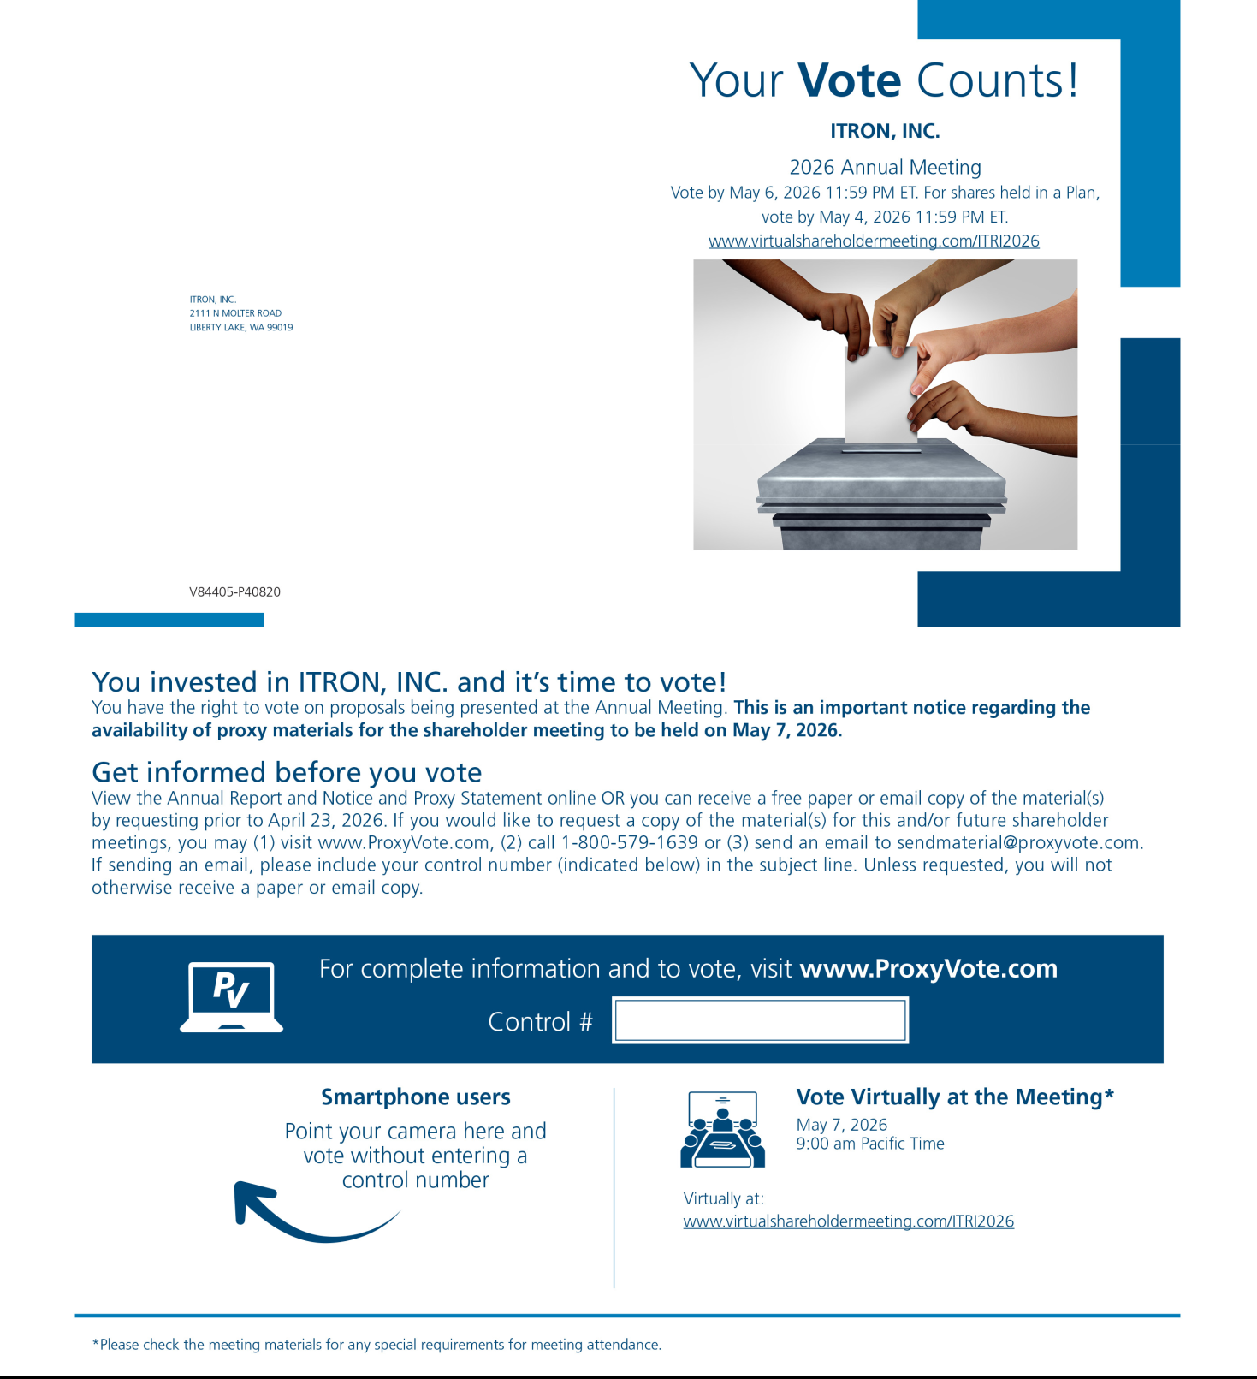

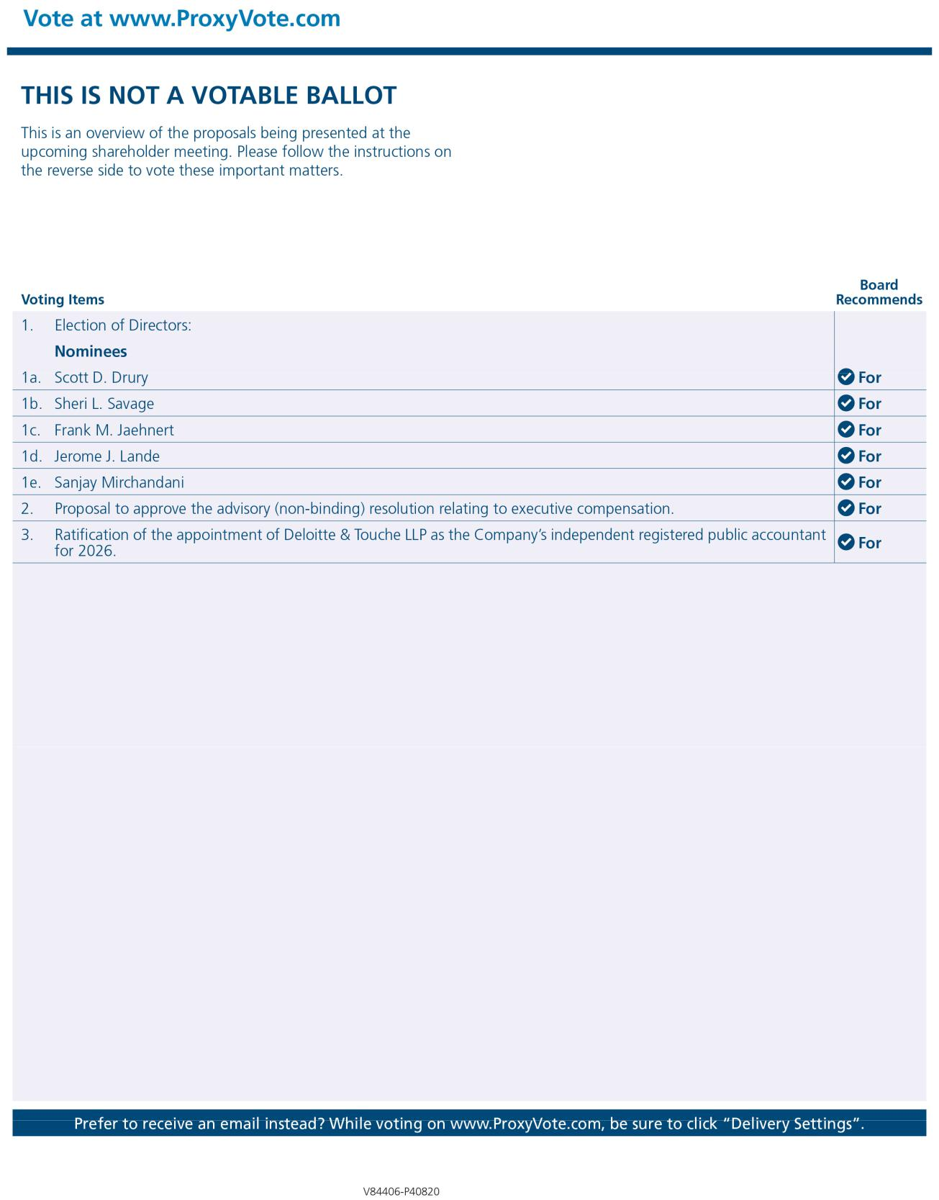

May 7, 2026 at

9:00 a.m., Pacific Time

