UNITED STATES

SECURITIES AND EXCHANGE COMMISSION
Washington, D.C. 20549

SCHEDULE 14A INFORMATION

Proxy Statement Pursuant to Section 14(a) of the

Securities Exchange Act of 1934
(Amendment No. )

Filed by the Registrant ☑ Filed by a Party other than the Registrant ☐

Check the appropriate box:

- Preliminary Proxy Statement

- Confidential, for Use of the Commission Only (as permitted by Rule 14a-6(e)(2))

- Definitive Proxy Statement

- Definitive Additional Materials

- Soliciting Material under Rule 14a-12

ITRON, INC.

(Name of registrant as specified in its charter)

(Name of person(s) filing proxy statement, if other than the registrant)

Payment of Filing Fee (Check the appropriate box):

- No fee required.

- Fee computed on table below per Exchange Act Rules 14a-6(i)(4) and 0-11.

  - Title of each class of securities to which transaction applies:

  - Aggregate number of securities to which transaction applies:

  - Per unit price or other underlying value of transaction computed pursuant to Exchange Act Rule 0-11 (set forth the amount on which the filing fee is calculated and state how it was determined):

  - Proposed maximum aggregate value of transaction:

  - Total fee paid:

- Fee paid previously with preliminary materials.

- Check box if any part of the fee is offset as provided by Exchange Act Rule 0-11(a)(2) and identify the filing for which the offsetting fee was paid previously. Identify the previous filing by registration statement number, or the Form or Schedule and the date of its filing.

  - Amount Previously Paid:

  - Form, Schedule or Registration Statement No.:

  - Filing Party:

  - Date Filed:

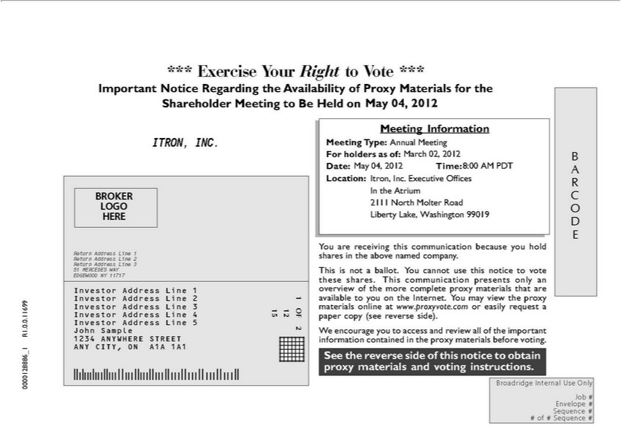

*** Exercise Your Right to Vote *** Important Notice Regarding the Availability of Proxy Materials for the Shareholder Meeting to Be Held on <mtgdate>. May 04, 2012 Meeting |  | ITRON, | .
Meeting Type: Annual Meeting <mtgtype> For holders as of: March 02, 2012 <recdate> B Date: May 04, 2012 Time: 8:00 AM PDT <mtgtime> A Location: Itron, Inc. Executive OfficesInformationRthe AtriumINC |  |  |  | .
BROKER 2111 North Molter Road LOGO O HERE Liberty Lake, Washington 99019 D E You are receiving this communication because you hold Return Address Line 1 shares in the above named |  |  |  | .
Return Address Line 2 Return Address Line 3 51 MERCEDES WAY This is not a ballot. You cannot use this notice to vote EDGEWOOD NY 11717 these shares. This communication presents only companyInvestor
Address Line 1 overview of the more complete proxy materials that are Investor Address Line 2 1 available you on the Internet. You may view the proxy | Address Line 3 materials online at
www.proxyvote.com or easily request a Investor Address Line 4 15 12 OF paper copy (see reverse side). Investor Address Line 5 R1.0.0.11699 John SampleInvestor2Wencourage you to access and review all of the important 1234 ANYWHERE STREET information contained in the proxy materials before voting. ANY CITY, ON A1A 1A1 _1 See the reverse side of this notice to obtain 0000128886 proxy materials and voting instructions. Broadridge Internal Use Only Job # Envelope # Sequence # # of # Sequence #

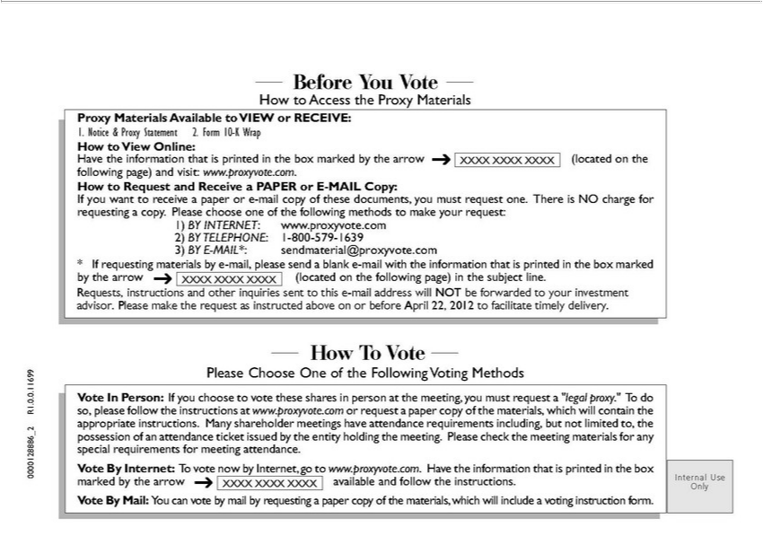

Before You Vote How to Access the Proxy Materials Proxy Materials Available to VIEW or RECEIVE: 1. Notice & Proxy Statement 2. Form 10-K Wrap How to View Online: Have the information that is
rinted in the box marked by the arrow XXXX XXXX XXXX (located on the following page) and visit: www.proxyvote.com. How to Request and Receive |  | PAPER or E-MAIL Copy: If you want to receive a
paper or -mail copy of these documents, you must request one. There is NO charge for requesting copy. Please choose one of the following methods to |  | your | 1) BY INTERNET:
www.proxyvote.com 2) BY TELEPHONE: 1-800-579-1639 3) BY E-MAIL*: sendmaterial@proxyvote.com * If requesting materials by -mail, please send |  | blank request:-mailwith the information that is printed in
the box marked by the arrow XXXX XXXX XXXX (located on the following page) in the subject line. Requests, instructions and other inquiries sent to thismake-mail address will NOT be forwarded to your
investment advisor. Please make the request as instructed above on or before April 22, 2012 to facilitate timely delivery. How To Vote Please Choose One of the Following Voting Methods Vote In Person: If you
choose to vote these shares in person at the meeting, you must request a “legal proxy.” To do R1.0.0.11699 so, please follow the instructions at www.proxyvote.com or request a paper copy of the materials,
which will contain the appropriate instructions. | shareholder meetings have attendance requirements including, but not limited to, the _2 possession of an attendance ticket issued by the entity holdi g the
meeting. Please check the meeting materials for Many0000128886 special requirements for meeting attendance. Vote By Internet: To vote now by Internet, go to www.proxyvote.com. Have the information that is
printed in the box marked by the arrow available and follow the instructions. Internal Use XXXX XXXX XXXX Only Vote By Mail: You can vote by mail by requesting a paper copy of the materials, which will include a voting instruction form.

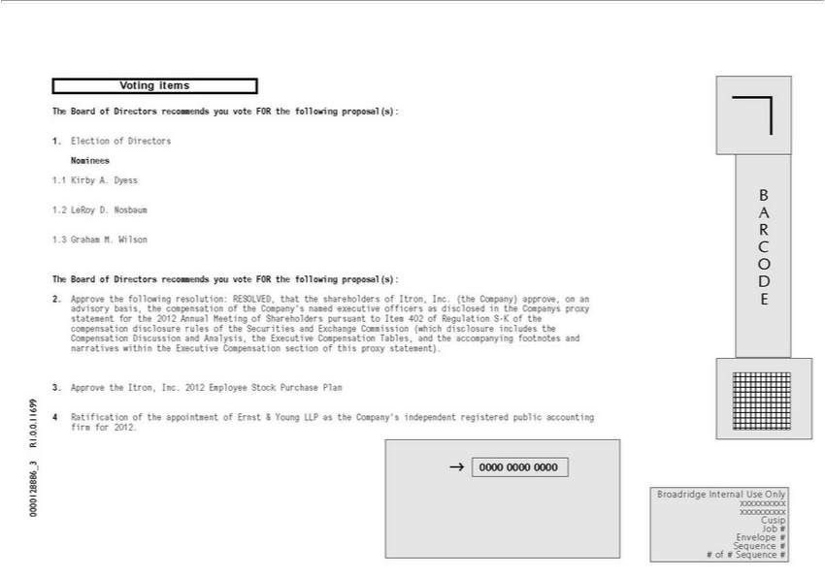

Voting items The Board of Directors recommends you vote FOR the following proposal(s): 1. Election of Directors Nominees 1.1 Kirby A. Dyess B 1.2 LeRoy D. Nosbaum A R 1.3 Graham M. Wilson C O The
Board of Directors recommends you vote FOR the following proposal(s): D 2. Approve the following resolution: RESOLVED, that the shareholders of Itron, Inc. (the Company) approve,_{Regulation} an E advisory basis,
the compensation of the Company’s named executive officers as disclosed in the Companys proxy statement for the 2012 Annual Meeting of Shareholders pursuant to Item 402 of S-K of the compensation disclosure rules of the Securities and Exchange Commission (which disclosure includes the Compensation Discussion and Analysis, the Executive Compensation Tables, and the accompanying footnotes and _{narratives} within the Executive Compensation section of this proxy statement). 3. Approve the Itron, Inc. 2012 Employee Stock Purchase Plan 4 Ratification of the appointment of Ernst & Young LLP as the Company’ independent registered public accounting R1.0.0.11699 firm for 2012. _3 ??0000 0000 0000 0000128886 Broadridge Internal Use Only xxxxxxxxxx xxxxxxxxxx Cusip Job # Envelope # Sequence # # of # Sequence #

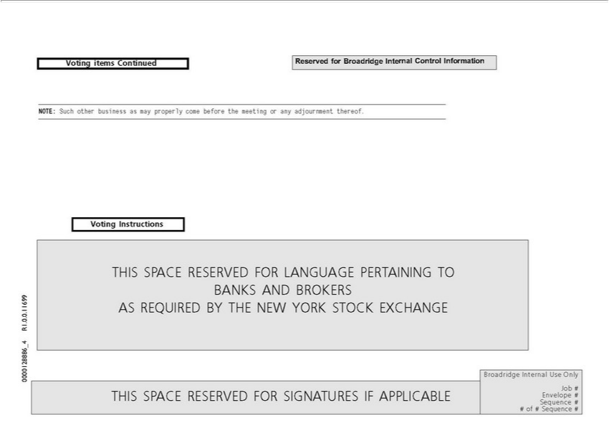

Voting items Continued Reserved for Broadridge Internal Control Information NOTE: Such other business as may properly come before the meeting or any adjournment thereof. Voting Instructio_{Internal}sTHIS
SPACE RESERVED FOR LANGUAGE PERTAINING^{TURES}O BANKS AND BROKERS R1.0.0.11699 AS REQUIRED BY THE NEW YORK STOCK EXCHANGE _4 0000128886 Broadridge Use
Only Job # THIS SPACE RESERVED FOR SIGNA IF APPLICABLE Envelope # Sequence # # of # Sequence #

