SECURITIES AND EXCHANGE COMMISSION

Washington, D.C. 20549

SCHEDULE 14A

(Rule 14a-101)

INFORMATION REQUIRED IN PROXY STATEMENT

SCHEDULE 14A INFORMATION

Proxy Statement Pursuant to Section 14(a) of

the Securities Exchange Act of 1934 (Amendment No. )

Filed by the Registrant ☒

Filed by a Party other than the Registrant ☐

Check the appropriate box:

- Preliminary proxy statement

- Definitive proxy statement

- Definitive Additional Materials

- Soliciting Material Pursuant to Rule 14a-11(c) or Rule 14a-12

- Confidential, For Use of the Commission Only (as permitted by Rule 14a-6(e)(2))

ITRON, INC.

(Name of Registrant as Specified in Its Charter)

(Name of Person(s) Filing Proxy Statement, if Other Than the Registrant)

Payment of Filing Fee (check the appropriate box):

- No fee required.

- Fee computed on table below per Exchange Act Rules 14a-6(i)(1) and 0-11.

(1) Title of each class of securities to which transaction applies:

- Aggregate number of securities to which transaction applies

- Per unit price or other underlying value of transaction computed pursuant to Exchange Act Rule 0-11 (set forth the amount on which the filing fee is calculated and state how it was determined):

- Proposed maximum aggregate value of transaction:

- Total fee paid:

- Fee paid previously with preliminary materials:

- Check box if any part of the fee is offset as provided by Exchange Act Rule 0-11(a)(2) and identify the filing for which the offsetting fee was paid previously. Identify the previous filing by registration statement number, or the form or schedule and the date of its filing.

- Amount previously paid:

- Form, Schedule or Registration Statement no.:

- Filing Party

- Date Filed:

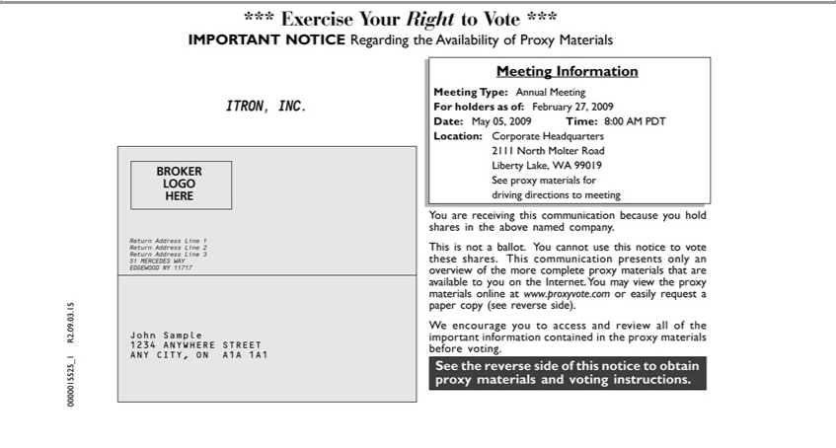

*** Exercise Your Right to Vote ***
^{ITRON,}MPORTANT NOTICE Regarding the Availability of Proxy Materials
INC.
BROKER
LOGO
HERE 1
Return Address Line ²
3
51 MERCEDES WAY
JohnEDGEWOODSample NY 11717
1234 ANYWHERE STREET
_{Meeting}ANYCITY,InformationONA1A 1A1
Type: Annual Meeting
Date:ForholdersMay05,as of:2009FebruaryTime:8:0027, 2009AM PDT
2111Location:NorthCorporateMolterRoadHeadquarters
Liberty Lake, WA 99019
drivingSeeproxydirectionsmaterialsto formeeting
You are receiving this communication because you hold shares in the above named company.
This is not_{materials}ballot. You cannot use this notice to vote these shares. This communication presents only an overview of the more complete proxy materials that are available to you on the Internet. You may view
the proxy online_{access}at www.proxyvote.com_{important}easily request_{information}paper copy (see reverse side).
^{See}
W encouragethereverseyousidetoof this noticeandreviewtoobtainall proxyofthe materials and voting instructions.containedin the proxy materials before voting.

0000015525_1 R2.09.03.15

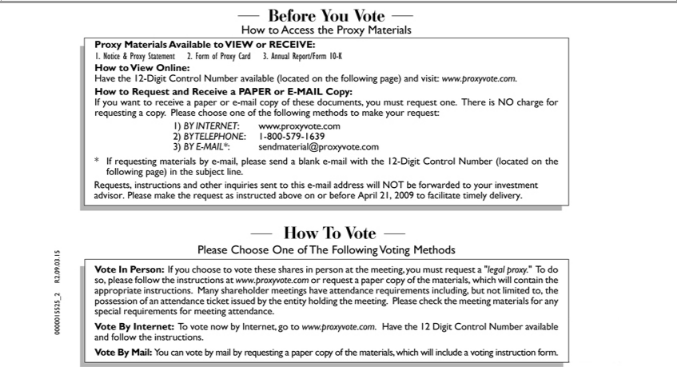

-Before You Vote-
How to Access the Proxy Materials
Proxy Materials Available to VIEW or RECEIVE:
1. Notice & Proxy Statement 2. Form of Proxy Card 3. Annual Report/Form 10-K
 | to View Online:
ave the 12-Digit Control Number available (located on the following page) and visit: www.proxyvote.com.
How to Request and Receive a PAPER or E-MAIL Copy:
If you want to receive a paper or |  |  |  | -mail copy of these documents, you must request one. There is NO charge for requesting a copy. Please choose one of the following methods to make your request:
1) | INTERNET www.proxyvote.com |  |  |  | .com
3) BY TELEPHONE:-MAIL*: |  |  | 1-800-579-1639 |  | .com
2)
* If requesting materialssendmaterial@proxyvoteby-mail,pleasesend a blank e-mail with the 12-Digit Control Number (located on the following page) in the subject line.
Requests, instructions and other inquiries sent to this e-mail address will NOT be forwarded to your investment advisor. Please make the request as instructed above on or April 21, 2009 to facilitate timely
delivery. |  | Vote-
-How T |  | Vote-
Please Choose One of The Following Voting Methods
Vote In Person: If you choose to vote these shares person at the meeting, you must request “legal proxy.” To do so, please follow the instructions at www.proxyvote.com or request a paper copy of the
materials, which will contain the appropriate instructions. |  |  |  |  |  | shareholder meetings have attend | requirements including, but not limited to, the possession of an attendance ticket issued by the entity
holding the meeting. Please check the meeting materials forMany special requirements for meeting attendance.
Vote By |  | Internet: To vote now by Internet, go to www.proxyvote.com. Have the 12 Digit Control Number available and follow the instructions.
 |  | Mail: You can vote by mail by requesting a paper copy of the materials, which will include a voting instruction form.
0000015525_2 R2.09.03.15

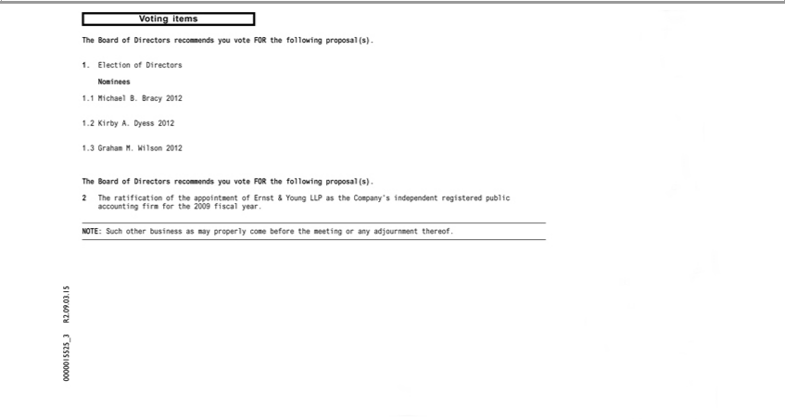

Voting items
The Board of Directors recommends you vote FOR the following proposal(s).
Nominees1.Election of Directors
1 Michael B. Bracy 2012
^{1.}2 Kirby A. Dyess 2012
3 Graham M. Wilson 2012
The Board of Directors recommends you vote FOR the following proposal(s).
2 The ratification of the appointment of Ernst & Young LLP as the _{Company’}s independent registered public accounting firm for the 2009 fiscal year.
NOTE: Such other business as may properly come before the meeting or adjournment thereof.

0000015525_3 R2.09.03.15



0000015525VotingInstructions_4R2.09.03.15

