UNITED STATES

SECURITIES AND EXCHANGE COMMISSION

Washington, D.C. 20549

FORM 8-K

CURRENT REPORT

Pursuant to Section 13 or 15(d) of the Securities Exchange Act of 1934

February 25, 2007
Date of Report (Date of Earliest Event Reported)

ITRON, INC.

(Exact Name of Registrant as Specified in its Charter)

Washington | 000-22418 |  | 91-1011792
(State or Other Jurisdiction |  | (Commission File No.) |  | (IRS Employer
of Incorporation) |  |  |  | Identification No.)
 |  | 2111 N. Molter Road, Liberty Lake, WA 99019
 |  | (Address of Principal Executive Offices, Zip Code)
 | (509) 924-9900
 |  | (Registrant’s Telephone Number, Including Area Code)

(Former Name or Former Address, if Changed Since Last Report)

Check the appropriate box below if the Form 8-K filing is intended to simultaneously satisfy the filing obligation of the registrant under any of the following provisions:

[ ] Written communications pursuant to Rule 425 under Securities Act (17 CFR 230.425)

[ ] Soliciting material pursuant to Rule 14a-12 under the Exchange Act (17 CFR 240.14a-12)

- ] Pre-commencement communications pursuant to Rule 14d-2(b) under the Exchange Act (17 CFR 240.14d-2(b))

- ] Pre-commencement communications pursuant to Rule 13e-4(c) under the Exchange Act (17 CFR 240.13e-4(c))

Item 1.01 Entry into a Material Definitive Agreement.

On February 25, 2007, Itron, Inc. (Itron) signed a stock purchase agreement to acquire Luxembourg-based Actaris Metering Systems (Actaris) for €800 million, plus the retirement of approximately €445 million in debt. At an exchange rate of 1.30 to the U.S. dollar, this totals approximately $1.6 billion.

The acquisition of Actaris, which is expected to close in the second quarter of 2007, will be funded by approximately $1.1 billion of fully-committed senior secured debt facilities, the net proceeds of a private placement of $235 million of common stock and cash on hand.

The acquisition is not subject to U.S. regulatory review. However, it will be subject to review by several regulatory bodies in countries outside the United States, including Ukraine, Germany, Brazil, Spain and Portugal, which require filings regardless of competitive product overlap.

Item 8.01 Other Events.

Itron agreed to sell 4,086,958 shares of common stock at $57.50 per share in a private placement. Settlement is expected March 1, 2007, subject to customary closing conditions. Itron is furnishing the following information, which was used in connection with the private placement:

- A copy of the press release dated February 25, 2007 announcing the acquisition of Actaris; and

- Other Actaris acquisition announcement information.

Item 9.01 Financial Statements and Exhibits.

- Exhibits.

The following exhibit is filed as part of this report:

Exhibit
Number |  | Description
99.1 |  | Press Release for Actaris Acquisition dated February 25, 2007.
99.2 |  | Other Actaris Acquisition Announcement Information
99.3 |  | Press Release announcing Private Placement of Equity dated February 25, 2007

The information presented in this Current Report on Form 8-K contains forward-looking statements and certain assumptions upon which such forward-looking statements are in part based. Numerous important factors, including those factors identified in Itron, Inc.’s Annual Report on Form 10-K and other of the Company’s filings with the Securities and Exchange Commission, and the fact that the assumptions set forth in this Current Report on Form 8-K could prove incorrect including the expectation that the private placement and the acquisition will be completed as scheduled, could cause actual results to differ materially from those contained in such forward-looking statements.

SIGNATURE

Pursuant to the requirements of the Securities Exchange Act of 1934, the registrant has duly caused this report to be signed on its behalf by the undersigned, hereunto duly authorized.

 | ITRON, INC.
Dated: February 25, 2007 |  | By: /s/ Steven M. Helmbrecht
 |  | Steven M. Helmbrecht
 |  | Sr. Vice President and Chief Financial Officer

 |  | EXHIBIT INDEX
Exhibit
Number |  | Description
99.1 |  | Press Release for Actaris Acquisition dated February 25, 2007.
99.2 |  | Other Actaris Acquisition Announcement Information
99.3 |  | Press Release announcing Private Placement of Equity dated February 25, 2007

Exhibit 99.1

Electric / Gas / Water
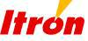
Information collection, analysis and applications

2111 North Molter Road

Liberty Lake, WA 99019

509.924.9900 Tel

509.891.3355 Fax

www.itron.com

FOR IMMEDIATE RELEASE

ITRON TO ACQUIRE ACTARIS METERING SYSTEMS FOR APPROXIMATELY $1.6 BILLION

- Acquisition of Luxembourg-based Actaris will create a worldwide market leader with more than 8,000 utility customers, expand Itron’s product offerings and increase access to global markets for electricity, gas and water meters and automated meter reading (AMR) technology;

- Combined company revenues and EBITDA in 2006 would have exceeded $1.6 billion and $274 million on a pro forma basis, respectively;

- Acquisition expected to be 20 to 30 cents accretive to non-GAAP earnings per share in 2007;

- Acquisition is fully financed and committed to by cash on hand, credit facilities provided by UBS and a $235 million private placement of equity, completed February 25, 2007.

SPOKANE, WA. — February 25, 2007 — Itron, Inc. (NASDAQ:ITRI) announced today that it has signed an agreement to acquire all of the stock and convertible bonds of Actaris Metering Systems (Actaris). The purchase price is €800 million plus the retirement of approximately €445 million of debt, which, at an exchange rate of 1.30, totals approximately $1.6 billion. The acquisition is expected to close in the second quarter of 2007.

Actaris is a global leader in electricity, gas and water metering, primarily outside of North America. Itron is the AMR leader and foremost electricity meter supplier in North America. The combined company will be one of the largest metering companies in the world. This acquisition will allow Actaris to offer Itron’s industry leading AMR and advanced metering infrastructure (AMI) technologies, software and systems expertise to customers outside of North America, and expand Actaris gas and water meter opportunities in North America.

For the twelve months ended December 31, 2006, Actaris generated revenue of approximately $1 billion and adjusted earnings before interest, taxes, depreciation and amortization (Adjusted EBITDA) of approximately $159 million.

“This acquisition, which will more than double Itron’s annual revenues, brings together two industry leaders and reunites two former Schlumberger divisions,” said LeRoy Nosbaum, chairman and CEO. “We have been looking for an investment that would allow Itron to bring its superior AMR technology and systems expertise to customers outside of North America. Our acquisition of Actaris is the perfect choice to combine their quality meters and established distribution channels with our expertise, which will ultimately bring more value to customers around the globe. No other meter or AMR provider offers a similar breadth and depth of solutions to their customers in the utility industry. This deal combines two companies that share a heritage, vision and passion for this industry and our combined customers.”

The acquisition of Actaris will be funded by approximately $1.1 billion of fully-committed senior secured debt facilities, the net proceeds of the private placement of approximately $235 million of common stock, which was completed February 25, 2007, and cash on hand.

Based on management’s expectation for closing in the second quarter, Itron expects that in 2007 the acquisition will add approximately $720 - $730 million in revenue, $0.20 - $0.30 in non-GAAP EPS and $110 - $115 million Adjusted EBITDA. These estimates are subject to financing terms and dependent on the closing date of the transaction and do not take into effect any intangible amortization expenses, in-process research and development expenses, charges related to inventory revaluation required under purchase accounting or other acquisition expenses.

“This acquisition brings together two very talented management teams, including many individuals who have worked together in previous careers with Schlumberger,” said Nosbaum. “These are both well-run companies that produce the highest quality products in very efficient and productive factories around the world. Bringing these companies together unites research and development, manufacturing and business synergies that no other provider can match.

“There can be no doubt that this acquisition represents a historical turning point in the life of our company and a significant commitment on the part of our investors,” commented Nosbaum. “But as I look at the strength of our businesses and cash flow, the talent of our combined management team and employee base, the synergies in our technology offerings, and the expanding opportunities in the global marketplace, I have no doubt that this is the right move - both strategically and financially - and the right time to take Itron to an entirely new level and drive strong future growth in our business on a global scale.”

CONDITIONS

The acquisition is not subject to U.S. regulatory review. However, it will be subject to review by several regulatory bodies in countries outside the U.S., including, Ukraine, Germany, Brazil, Spain and Portugal, which require filings regardless of competitive product overlap.

Itron has received a senior secured underwritten agreement from UBS to finance the transaction. Additionally, UBS acted as exclusive financial advisor to the Company and sole placement agent for the private placement of common stock. Gibson, Dunn & Crutcher LLP and Perkins Coie LLP acted as legal advisors to Itron. Mayer, Brown, Rowe & Maw LLP acted as legal advisor to Actaris.

About Itron:

Itron is a leading technology provider and critical source of knowledge to the global energy and water industries. Nearly 3,000 utilities worldwide rely on Itron’s award-winning technology to provide the knowledge they require to optimize the delivery and use of energy and water. Itron creates value for its clients by providing industry-leading solutions for electricity metering; meter data collection; energy information management; demand response; load forecasting, analysis and consulting services; distribution system design and optimization; web-based workforce automation; and enterprise and residential energy management. To know more, start here: www.itron.com.

About Actaris:

Actaris is a world leader in the design and manufacture of meters and associated systems for the electricity, gas, water and heat markets, providing innovative products and systems that integrate the latest technologies to meet the evolving needs of public or private energy and water suppliers, utility services and industrial companies worldwide. Actaris is active in more than 30 countries, employs approximately 6,000 people in 60 locations and has 29 manufacturing sites worldwide. The company has a cumulative installed base of some 300 million electricity, gas and water meters throughout the world. To know more, start here: www.actaris.com.

Forward Looking Statements:

This release contains forward-looking statements concerning our expectations about our operations, financial performance, sales, earnings and cash flows. These statements reflect our current plans and expectations and are based on information currently available. They rely on a number of assumptions and estimates, which could be inaccurate, and which are subject to risks and uncertainties that could cause our actual results to vary materially from those anticipated. Risks and uncertainties include the rate and timing of customer demand for our products, rescheduling of current customer orders, changes in estimated liabilities for product warranties, changes in laws and regulations, our dependence on new product development and intellectual property, future acquisitions, changes in foreign exchange rates, changes in estimates for stock based compensation and other factors which are more fully described in our Annual Report on Form 10-K for the year ended December 31, 2006 and other reports on file with the Securities and Exchange Commission. Itron undertakes no obligation to update publicly or revise any forward-looking statements, including our business outlook.

Non-GAAP Financial Information:

To supplement our consolidated financial statements presented in accordance with GAAP, we use certain non-GAAP financial measures, including non-GAAP diluted EPS and Adjusted EBITDA. We provide these non-GAAP financial measures because we believe they provide greater transparency and represent supplemental information used by management in its financial and operational decision making. Specifically, these non-GAAP financial measures are provided to enhance investors’ overall understanding of our current financial performance and our future anticipated performance by excluding infrequent costs associated with acquisitions, restructurings and non-cash stock based compensation. We exclude these expenses in our non-GAAP financial measures as we believe that they are a measure of our core business that is not subject to the variations of expenses associated with these infrequently occurring or non-cash items. Non-GAAP performance measures should be considered in addition to, and not as a substitute for, results prepared in accordance with GAAP. Finally, our non-GAAP financial measures may be different from those reported by other companies.

Pro Forma Information:

The 2006 historical information for Itron and Actaris and the pro forma information for the combined company is preliminary and has not been audited. Actaris financial results have not been prepared in accordance with US GAAP and adjustments have been made to the Actaris historical results to reflect US GAAP, however, not all adjustments have been made. These adjustments, which are reflected in this press release, have not been audited and are preliminary and subject to change. Audited historical financial statements for Actaris and complete pro forma financial information for the combined company will not be available until up to 75 days after the transaction closes. Audited financial statements for Itron are available in our 2006 Form 10-K filed February 23, 2007.

Acquisition Conference Call:

Itron will host a conference call to discuss details of the acquisition contained in this release at 5 a.m. (PST) on February 26, 2007. The call will be webcast in a listen only mode and can be accessed online at www.itron.com, “Investors - Events.” The live webcast will begin at 5 a.m. (PST). The webcast replay will begin approximately 2 hours after the conclusion of the live call and will be available for two weeks. A telephone replay of the call will also be available approximately one hour after the conclusion of the live call, for 48 hours, and is accessible by dialing (888) 203-1112 (Domestic) or (719) 457-0820 (International), entering passcode # 2042318.

For additional information on the transaction see “Actaris Acquisition Presentation” at www.itron.com.

Itron, Inc. contact:

Deloris Duquette

Vice-president, Investor Relations and Corporate Communications

- 891-3523 Deloris.duquette@itron.com

(Unaudited, in thousands)

Revenue

Adjusted EBITDA:

GAAP net income

Interest income

Interest expense

Income tax provision (benefit)

Depreciation and amortization

Non-cash stock based compensation expense Restructuring costs

Adjusted EBITDA

ITRON, INC.

PRO FORMA REVENUE AND RECONCILIATION OF ADJUSTED EBITDA

TO MOST DIRECTLY COMPARABLE GAAP FINANCIAL MEASURE

For the twelve months ended December 31, 2006

 |  | Actaris EUR |  |  | Actaris USD |  | Itron |  |  |  |  | Pro Forma
 |  | € 780,737 |  | $ | 1,014,958 |  | $ | 644,042 |  | $ |  | 1,659,000
 |  | € 39,629 |  | $ | 51,518 |  | $ | 33,759 |  | $ |  | 85,277
 |  | (303) |  |  | (394) |  |  | (9,497) |  |  |  | (9,891)
 |  | 36,129 |  |  | 46,968 |  |  | 17,785 |  |  |  | 64,753
 |  | 17,187 |  |  | 22,343 |  |  | 18,476 |  |  |  | 40,819
 |  | 26,323 |  |  | 34,220 |  |  | 46,234 |  |  |  | 80,454
 |  | - |  |  | - |  |  | 8,646 |  |  |  | 8,646
 |  | 3,125 |  |  | 4,062 |  |  | - |  |  |  | 4,062
 | € | 122,091 |  | $ | 158,718 |  | $ | 115,403 |  | $ |  | 274,121

Actaris financial results are unaudited and are not prepared in accordance with US GAAP. US dollars calculated at a rate of 1.30 US dollars per Euro.

Exhibit 99.2
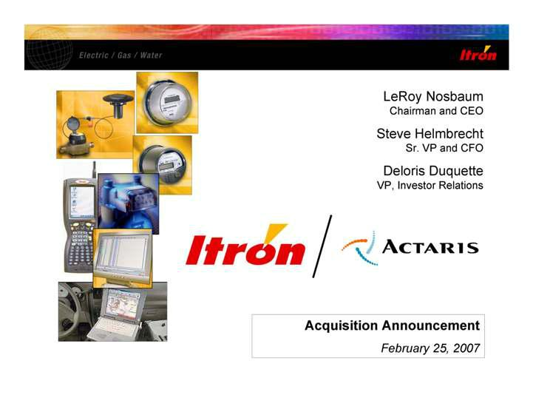

LeRoy Nosbaum Chairman and CEO Steve Helmbrecht Sr. VP and CFO Deloris Duquette VP, Investor Relations Acquisition Announcement February 25, 2007 Itron Actaris

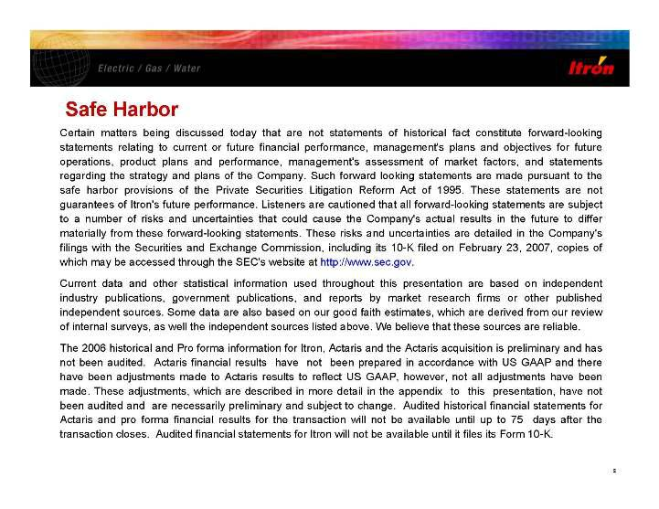

Safe Harbor Certain matters being discussed today that are not statements of historical fact constitute forward-looking statements relating to current or future financial performance, management's plans and objectives for future operations, product plans and performance, management's assessment of market factors, and statements regarding the strategy and plans of the Company. Such forward looking statements are made pursuant to the safe harbor provisions of the Private Securities Litigation Reform Act of 1995. These statements are not guarantees of Itron's future performance. Listeners are cautioned that all forward-looking statements are subject to a number of risks and uncertainties that could cause the Company's actual results in the future to differ materially from these forward-looking statements. These risks and uncertainties are detailed in the Company's filings with the Securities and Exchange Commission, including its 10-K filed on February 23, 2007, copies of which may be accessed through the SEC's website at http://www.sec.gov. Current data and other statistical information used throughout this presentation are based on independent industry publications, government publications, and reports by market research firms or other published independent sources. Some data are also based on our good faith estimates, which are derived from our review of internal surveys, as well the independent sources listed above. We believe that these sources are reliable. The 2006 historical and Pro forma information for Itron, Actaris and the Actaris acquisition is preliminary and has not been audited. Actaris financial results have not been prepared in accordance with US GAAP and there have been adjustments made to Actaris results to reflect US GAAP, however, not all adjustments have been made. These adjustments, which are described in more detail in the appendix to this presentation, have not been audited and are necessarily preliminary and subject to change. Audited historical financial statements for Actaris and pro forma financial results for the transaction will not be available until up to 75 days after the transaction closes. Audited financial statements for Itron will not be available until it files its Form 10-K.

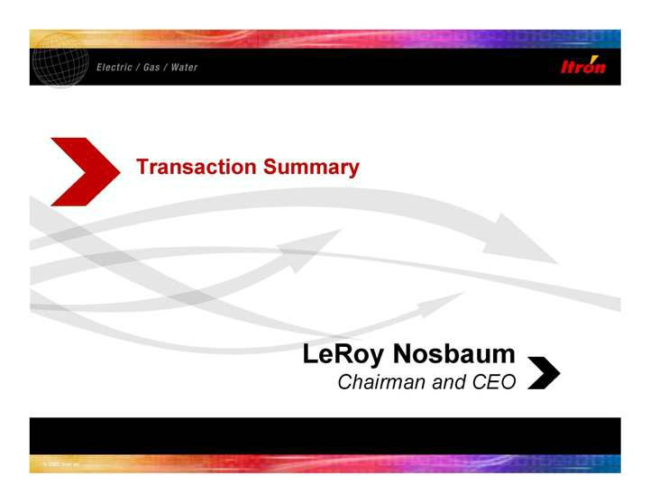

Transaction Summary LeRoy Nosbaum Chairman and CEO

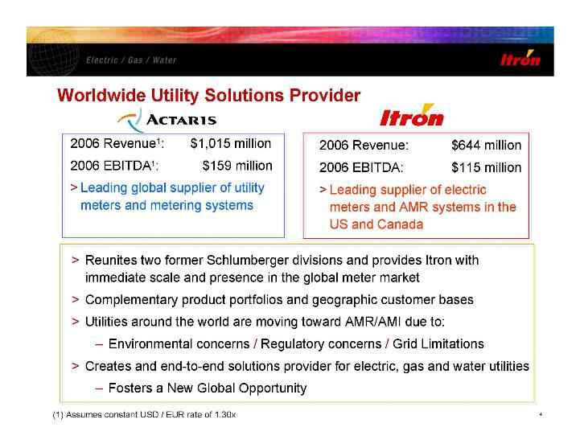

Actaris Itron Worldwide Utility Solutions Provider 2006 Revenue1: $1,015 million 2006 EBITDA1: $159 million > Leading global supplier of utility meters and metering systems > Reunites two former Schlumberger divisions and provides Itron with immediate scale and

presence in the global meter market > Complementary product portfolios and geographic customer bases > Utilities around the world are moving toward AMR/AMI due to: - Environmental concerns / Regulatory concerns / Grid Limitations > Creates and end-to-end solutions

provider for electric, gas and water utilities - Fosters a New Global Opportunity 2006 Revenue: $644 million 2006 EBITDA: $115 million > Leading supplier of electric meters and AMR systems in the US and Canada (1) Assumes constant USD / EUR rate of 1.30x

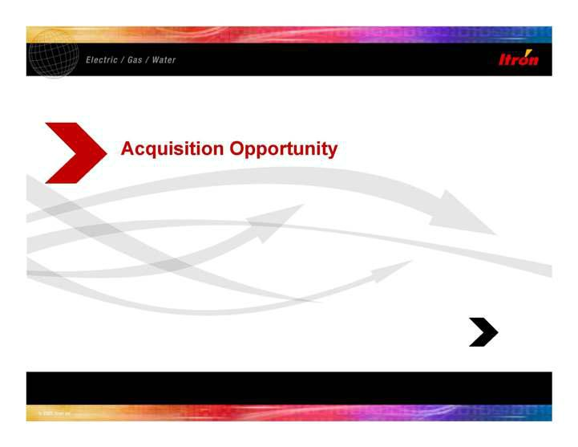

Acquisition Opportunity

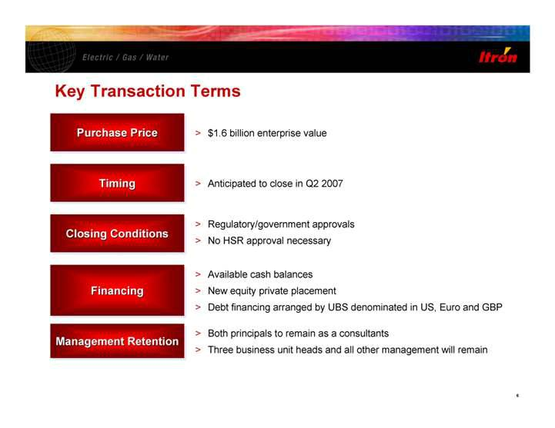

Key Transaction Terms Purchase Price Purchase Price Purchase Price > $1.6 billion enterprise value Timing Timing Timing > Anticipated to close in Q2 2007 Closing Conditions Closing Conditions Closing Conditions > Regulatory/government approvals > No HSR approval necessary Management Retention Management Retention Management Retention Financing Financing Financing > Available cash balances > New equity private placement > Debt financing arranged by UBS denominated in US, Euro and GBP > Both principals to remain as a consultants > Three business unit heads and all other management will remain

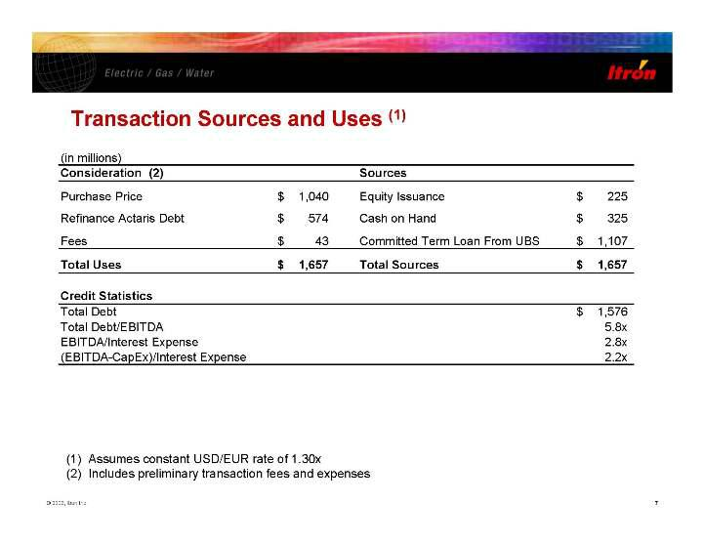

Transaction Sources and Uses (1) (1) Assumes constant USD/EUR rate of 1.30x (2) Includes preliminary transaction fees and expenses (in millions) Consideration (2) Sources Purchase Price 1,040 $ Equity Issuance 225 $ Refinance Actaris Debt 574 $ Cash on Hand 325 $ Fees 43 $ Committed Term Loan From UBS 1,107 $ Total Uses 1,657 $ Total Sources 1,657 $ Credit Statistics Total Debt 1,576 $ Total Debt/EBITDA 5.8x EBITDA/Interest Expense 2.8x (EBITDA-CapEx)/Interest Expense 2.2x

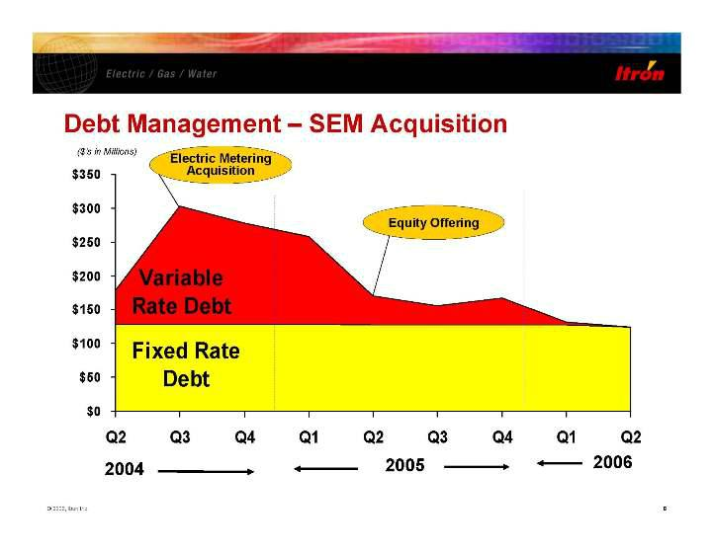

$0 $50 $100 $150 $200 $250 $300 $350 Q2 Q3 Q4 Q1 Q2 Q3 Q4 Q1 Q2 2006 2005 2004 ($’s in Millions) Debt Management - SEM Acquisition Electric Metering Acquisition Equity Offering Fixed Rate Debt Variable Rate Debt

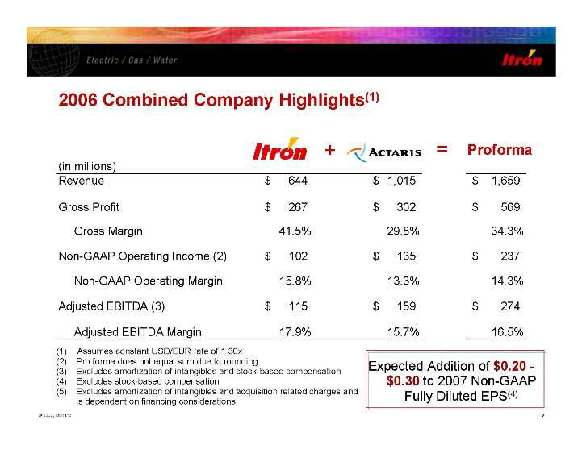

Itron Actaris 2006 Combined Company Highlights(1) + = Proforma Expected Addition of $0.20 - $0.30 to 2007 Non-GAAP Fully Diluted EPS(4) (1) Assumes constant USD/EUR rate of 1.30x (2) Pro forma does not equal sum due to rounding (3) Excludes amortization of intangibles and stock-based compensation (4) Excludes stock-based compensation (5) Excludes amortization of intangibles and acquisition related charges and is dependent on financing considerations (in millions) Revenue 644 $ 1,015 $ 1,659 $ Gross Profit 267 $ 302 $ 569 $ Gross Margin 41.5% 29.8% 34.3% Non-GAAP Operating Income (2) 102 $ 135 $ 237 $ Non-GAAP Operating Margin 15.8% 13.3% 14.3% Adjusted EBITDA (3) 115 $ 159 $ 274 $ Adjusted EBITDA Margin 17.9% 15.7% 16.5%

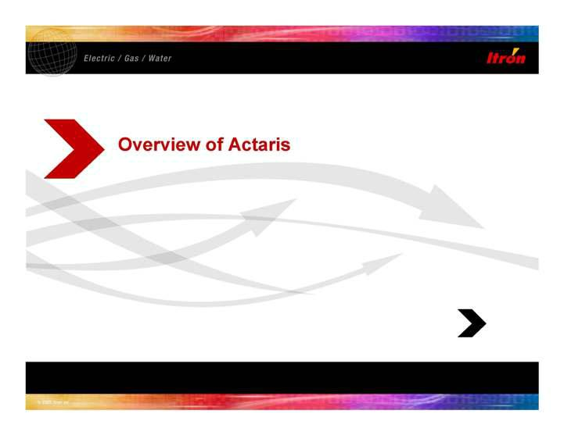

Overview of Actaris

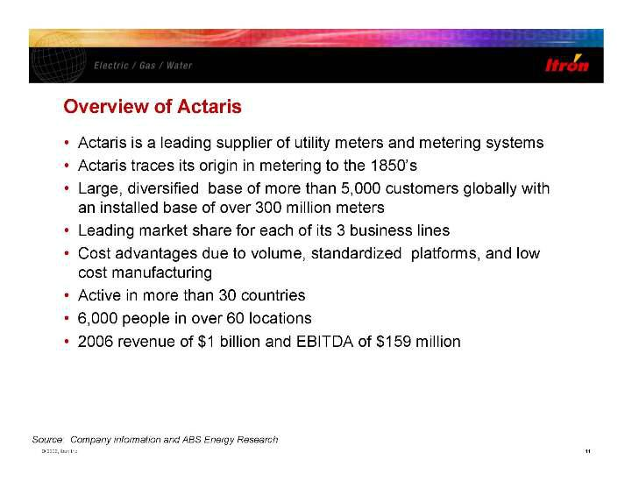

Overview of Actaris • Actaris is a leading supplier of utility meters and metering systems • Actaris traces its origin in metering to the 1850’s • Large, diversified base of more than 5,000 customers globally with an installed base of over 300 million meters • Leading market share for each of its 3 business lines • Cost advantages due to volume, standardized platforms, and low cost manufacturing • Active in more than 30 countries • 6,000 people in over 60 locations • 2006 revenue of $1 billion and EBITDA of $159 million Source: Company information and ABS Energy Research

Electricity Manufacturing Gas Manufacturing Water Manufacturing Heat Manufacturing Other Operations Research & Engineering Key Locations Felixstowe Hameln Barcelona Massy Greenwood Owenton Buenos Aires Chongqing Gödöllö Kiev Argenteuil Karlsruhe Stretford Reims Chasseneuil Naples Oldenburg Adelaide Kuala Lumpur Jakarta Dordrecht Porto Asti Haguenau Mâcon Santiago Americana Campinas Al-Khobar Atlantis 300 860 330 3,310 1,180 # of Employees 300 860 330 3,310 1,180 Actaris Worldwide Footprint

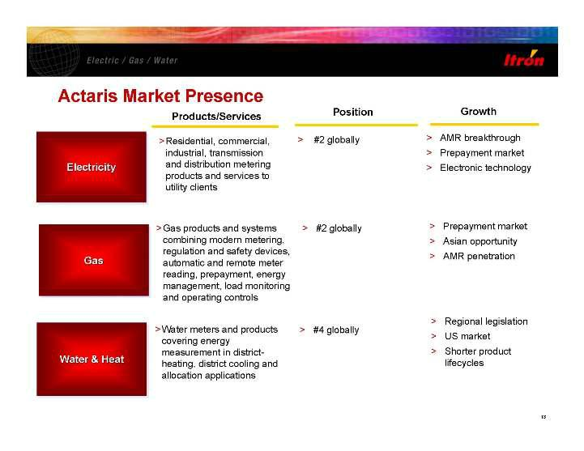

Actaris Market Presence Products/Services >Residential, commercial, industrial, transmission and distribution metering products and services to utility clients Position > #2 globally Growth > AMR breakthrough > Prepayment market > Electronic technology Electricity Electricity Electricity >Gas products and systems combining modern metering, regulation and safety devices, automatic and remote meter reading, prepayment, energy management, load monitoring and operating controls > #2 globally > Prepayment market > Asian opportunity > AMR penetration Gas Gas Gas >Water meters and products covering energy measurement in districtheating, district cooling and allocation applications > #4 globally > Regional legislation > US market > Shorter product lifecycles Water & Heat Water

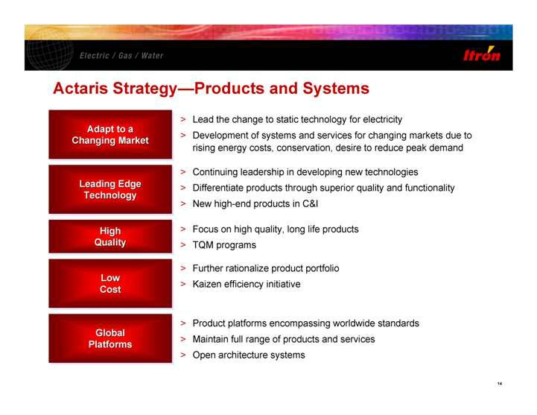

Actaris Strategy—Products and Systems Adapt to a Changing Market Adapt to a Adapt to a Changing Changing Market Market > Lead the change to static technology for electricity > Development of systems and services for changing markets due to rising energy costs, conservation, desire to reduce peak demand Leading Edge Technology Leading Edge Leading Edge Technology Technology > Continuing leadership in developing new technologies > Differentiate products through superior quality and functionality > New high-end products in C&I High Quality High High Quality Quality > Focus on high quality, long life products > TQM programs Global Platforms Global Global Platforms Platforms Low Cost Low Low Cost Cost > Further rationalize product portfolio > Kaizen efficiency initiative > Product platforms encompassing worldwide standards > Maintain full range of products and services > Open architecture systems

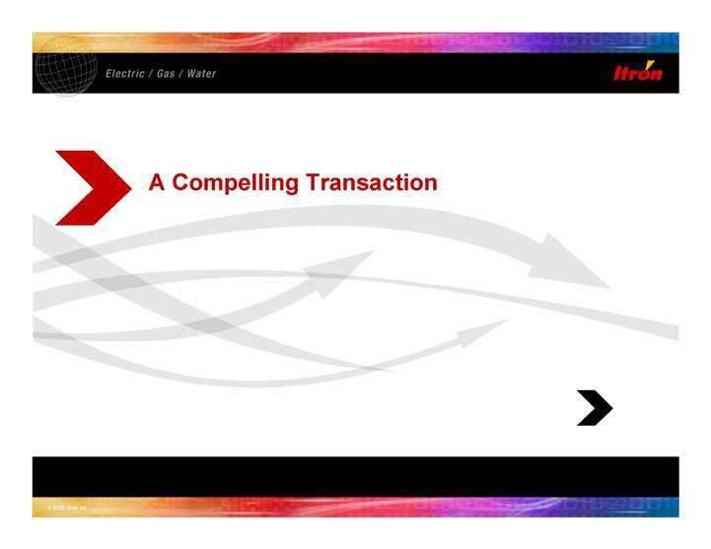

A Compelling Transaction

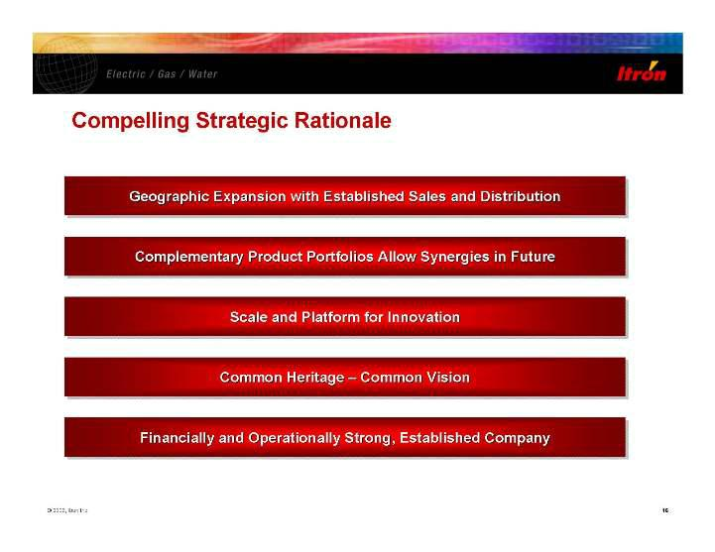

Compelling Strategic Rationale Geographic Expansion with Established Sales and Distribution Geographic Expansion with Established Sales and Distribution Geographic Expansion with Established Sales and Distribution Complementary Product Portfolios Allow Synergies in Future Complementary Product Portfolios Allow Synergies in Future Complementary Product Portfolios Allow Synergies in Future Scale and Platform for Innovation Scale and Platform for Innovation Scale and Platform for Innovation Financially and Operationally Strong, Established Company Financially and Operationally Strong, Established Company Financially and Operationally Strong, Established Company Common Heritage - Common Vision

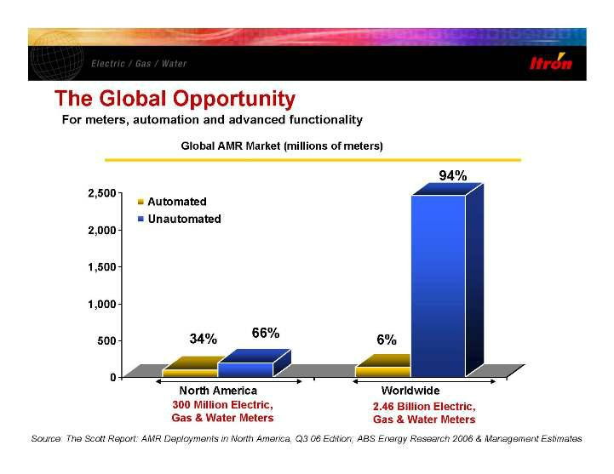

The Global Opportunity Global AMR Market (millions of meters) 34% 66% 6% 94% Source: The Scott Report: AMR Deployments in North America, Q3 06 Edition; ABS Energy Research 2006 & Management Estimates 300 Million Electric, Gas & Water Meters 2.46 Billion Electric, Gas & Water Meters For meters, automation and advanced functionality 2,500 North America Worldwide Automated Unautomated 0 500 1,000 1,500 2,000 2,500

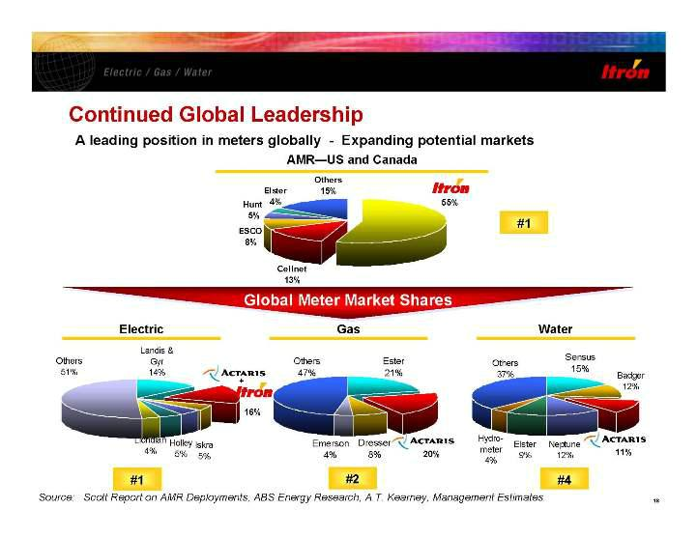

Continued Global Leadership Global Meter Market Shares Global Meter Market Shares AMR—US and Canada Electric Gas Water Elster 4% Hunt 5% ESCO 8% Cellnet 13% Itron 55% Others 15% Source: Scott Report on AMR Deployments, ABS Energy Research, A.T. Kearney, Management Estimates 18 55% #1 #1 #2 #2 #4 #4 16% 20% 11% #1 Electric Gas Water Others 51% Landis & Gyr 14% Dresser 8% Emerson 4% Ester 21% Others 47% Neptune 12% Elster 9% Hydrometer 4% Others 37% Badger 12% Sensus 15% Continued Global Leadership Global Meter Market Shares Global Meter Market Shares AMR—US and Canada Electric Gas Water Elster 4% Hunt 5% ESCO 8% Cellnet 13% Itron 55% Others 15% Source: Scott Report on AMR Deployments, ABS Energy Research, A.T. Kearney, Management Estimates 18 55% #1 #1 #2 #2 #4 #4 16% 20% 11% A leading position in meters globally - Expanding potential markets

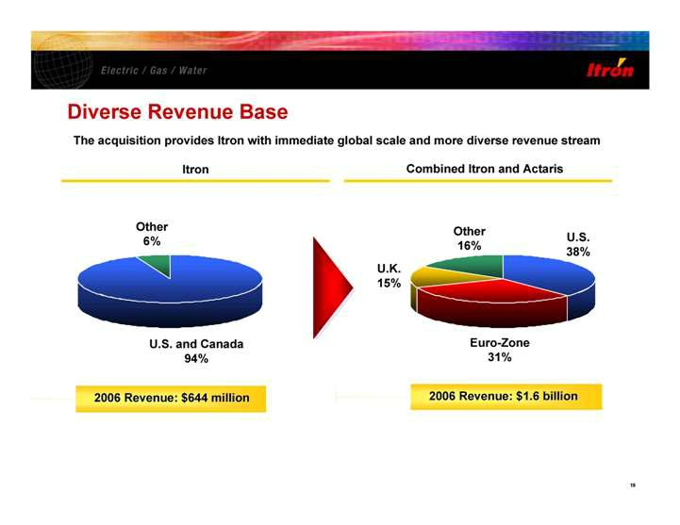

Diverse Revenue Base Itron Combined Itron and Actaris U.S. 38% Euro-Zone 31% U.K. 15% Other 16% U.S. and Canada 94% Other 6% 2006 Revenue: $1.6 billion 2006 Revenue: $1.6 billion 2006 Revenue: $644 million 2006 Revenue: $644 million The acquisition provides Itron with immediate global scale and more diverse revenue stream

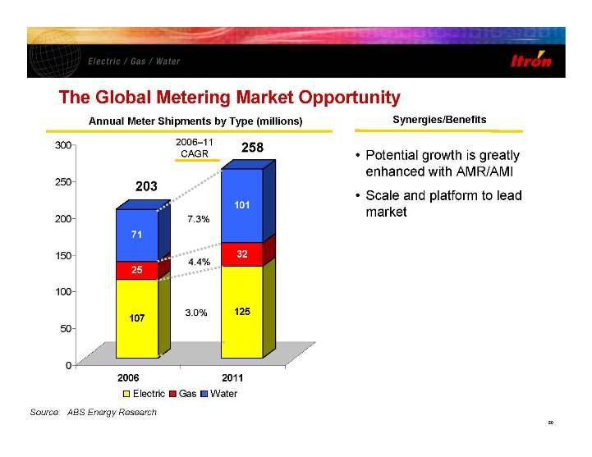

The Global Metering Market Opportunity Source: ABS Energy Research 107 25 71 125 32 101 0 50 100 150 200 250 300 2006 2011 Electric Gas Water Annual Meter Shipments by Type (millions) 258 203 • Potential growth is greatly enhanced with AMR/AMI • Scale and platform to lead market 2006-11 CAGR 7.3% 4.4% 3.0% Synergies/Benefits

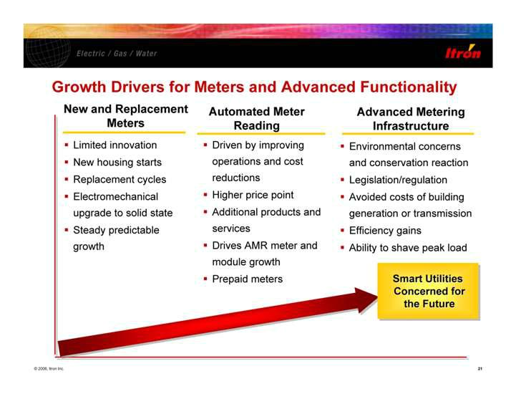

Growth Drivers for Meters and Advanced Functionality Advanced Metering Infrastructure New and Replacement Meters Limited innovation New housing starts Replacement cycles Electromechanical upgrade to solid state Steady predictable growth Automated Meter Reading Driven by improving operations and cost reductions Higher price point Additional products and services Drives AMR meter and module growth Prepaid meters Environmental concerns and conservation reaction Legislation/regulation Avoided costs of building generation or transmission Efficiency gains Ability to shave peak load Smart Utilities Concerned for the Future Smart Utilities Smart Utilities Concerned for Concerned for

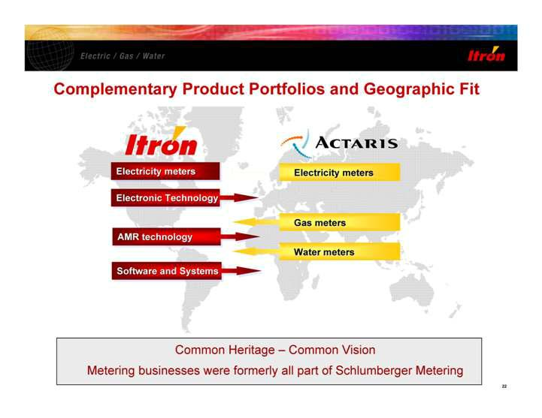

Complementary Product Portfolios and Geographic Fit Electricity meters Electricity meters Gas meters Gas meters Water meters Water meters Common Heritage - Common Vision Metering businesses were formerly all part of Schlumberger Metering Electricity meters Electricity meters Electricity meters AMR technology AMR technology AMR technology Electronic Technology Electronic Technology Electronic Technology Software and Systems

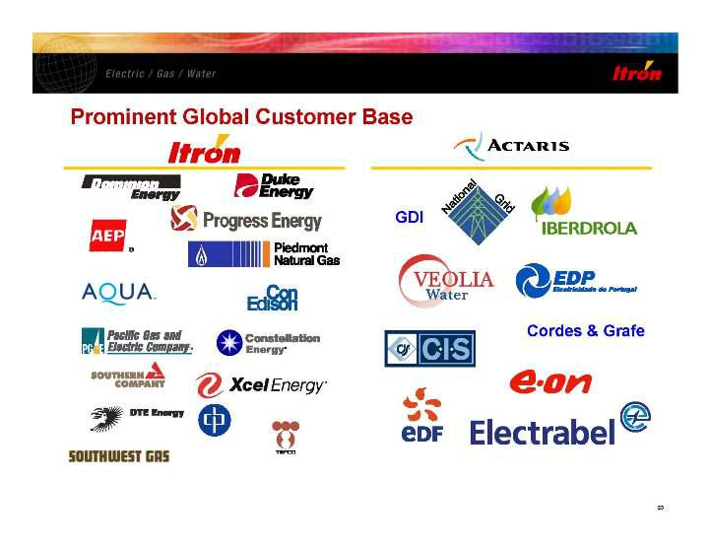

Prominent Global Customer Base Itron Actaris Dominion Energy Duke Energy Progress Energy AEP AQUA Piedmon Natural Gas Con Edison Pacific Gas and Electric Company Constellation Energy Southern Company Xcel Energy DTE Energy Southwest Gas TEPCO cp GDI National Grid Iberdrola Veolia Water EDP Electricdade de Portugal CIS Cordes & Grafe E.ON EDF Electrabel

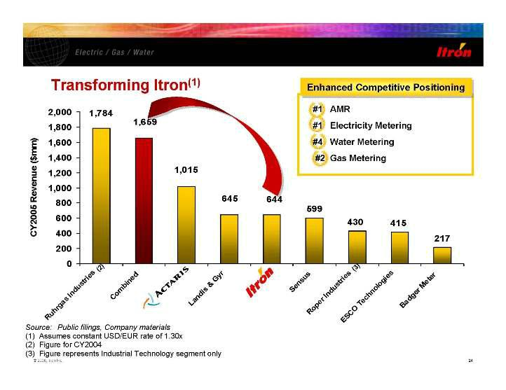

Transforming Itron(1) Enhanced Competitive Positioning Enhanced Competitive Positioning Enhanced Competitive Positioning Source: Public filings, Company materials (1) Assumes constant USD/EUR rate of 1.30x (2) Figure for CY2004 (3) Figure represents Industrial Technology segment only #1 #1 #1 #1 #1 AMR #1 Electricity Metering #4 Water Metering #2 Gas Metering 599 430 415 217 644 645 1,015 1,659 1,784 0 200 400 600 800 1,000 1,200 1,400 1,600 1,800 2,000 Ruhrgas Industries (2) Combined Landis & Gyr Sensus Roper Industries (3) ESCO Technologies Badger Meter Actaris Itron

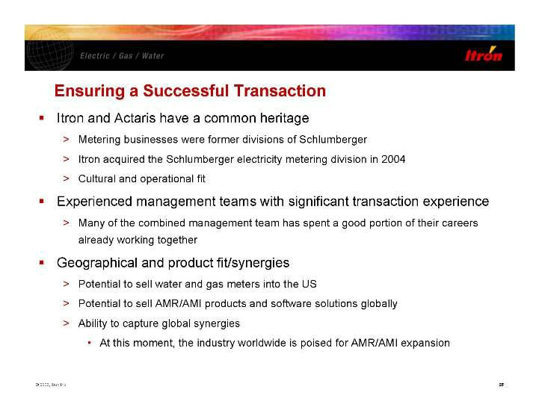

Ensuring a Successful Transaction Itron and Actaris have a common heritage > Metering businesses were former divisions of Schlumberger > Itron acquired the Schlumberger electricity metering division in 2004 > Cultural and operational fit Experienced management teams with significant transaction experience > Many of the combined management team has spent a good portion of their careers already working together Geographical and product fit/synergies > Potential to sell water and gas meters into the US > Potential to sell AMR/AMI products and software solutions globally > Ability to capture global synergies • At this moment, the industry worldwide is poised for AMR/AMI expansion

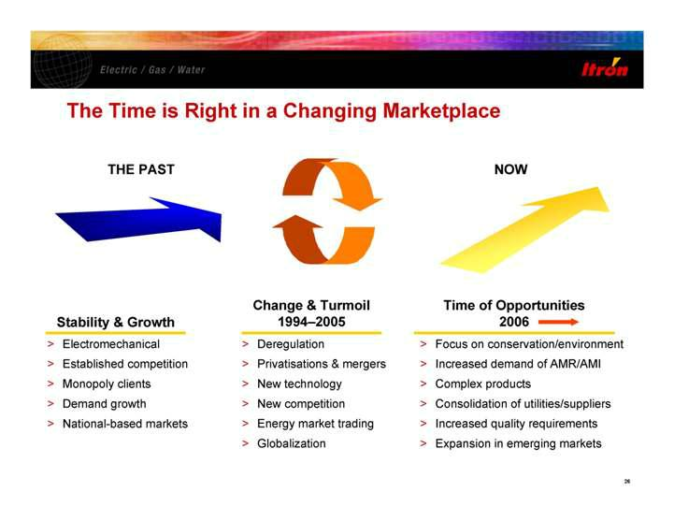

The Time is Right in a Changing Marketplace > Deregulation > Privatisations & mergers > New technology > New competition > Energy market trading > Globalization Change & Turmoil 1994-2005 > Focus on conservation/environment > Increased demand of AMR/AMI > Complex products > Consolidation of utilities/suppliers > Increased quality requirements > Expansion in emerging markets Time of Opportunities 2006 NOW > Electromechanical > Established competition > Monopoly clients > Demand growth > National-based markets Stability & Growth THE PAST

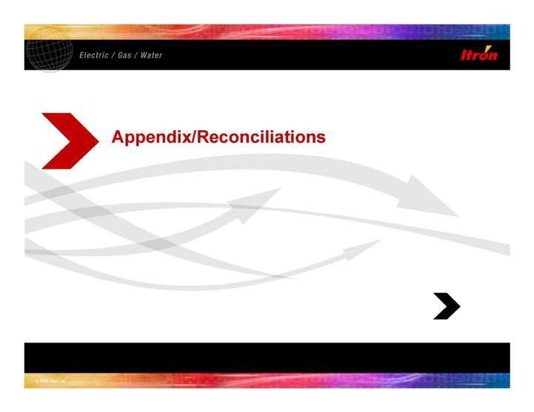

Appendix/Reconciliations

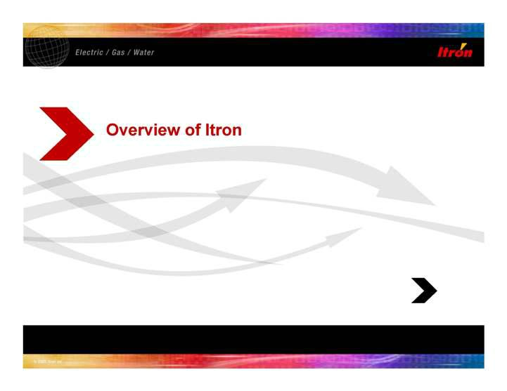

Overview of Itron

Itron Customers > More than 2,200 handheld meter reading customers in over 60 countries • Hardware and meter data collection software > Electricity meter customers in U.S. and Canada • Nearly every IOU, Muni and Co-Op > More than 1,500 AMR customers • > 55 million endpoints shipped (electric, gas and water) • AMR endpoints shipped to >70% of IOUs • Fixed networks at more than 20 customers > C&I meter data collection software at > 90% of the largest electric utilities in U.S. Well Known Customers Key Highlights Dominion Energy Duke Energy Progress Energy AEP Piedmont Natural Gas AQUA National Grid Con Edison Pacific Gas and Electric Company Constellation Energy Southern Company Xcel Energy DTE Energy cp Southwest Gas TEPCO

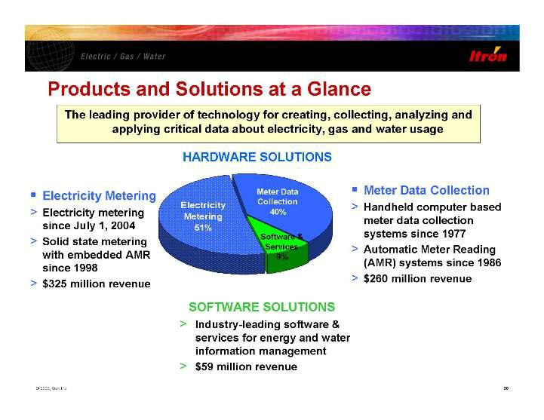

Products and Solutions at a Glance Software & Services 9% Meter Data Collection 40% Electricity Metering 51% HARDWARE SOLUTIONS HARDWARE SOLUTIONS SOFTWARE SOLUTIONS SOFTWARE SOLUTIONS Meter Data Collection > Handheld computer based meter data collection systems since 1977 > Automatic Meter Reading (AMR) systems since 1986 > $260 million revenue Electricity Metering > Electricity metering since July 1, 2004 > Solid state metering with embedded AMR since 1998 > $325 million revenue > Industry-leading software & services for energy and water information management > $59 million revenue The leading provider of technology for creating, collecting, analyzing and applying critical data about electricity, gas and water usage

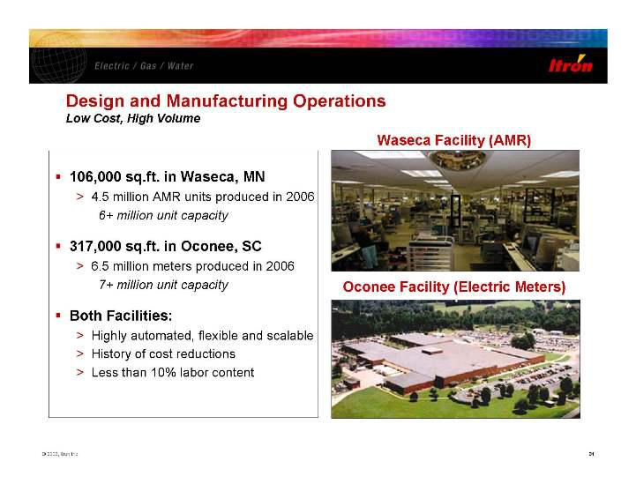

Oconee Facility (Electric Meters) 106,000 sq.ft. in Waseca, MN > 4.5 million AMR units produced in 2006 6+ million unit capacity 317,000 sq.ft. in Oconee, SC > 6.5 million meters produced in 2006 7+ million unit capacity Both Facilities: > Highly automated, flexible and scalable > History of cost reductions > Less than 10% labor content Waseca Facility (AMR) Design and Manufacturing Operations Low Cost, High Volume

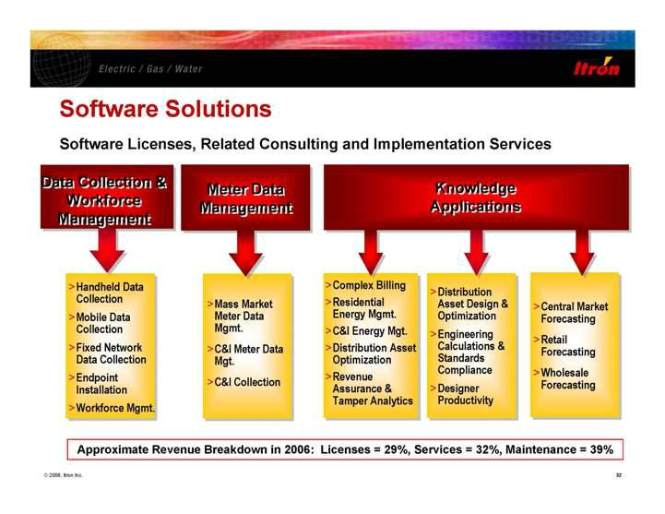

Software Solutions Approximate Revenue Breakdown in 2006: Licenses = 29%, Services = 32%, Maintenance = 39% >Complex Billing >Residential Energy Mgmt. >C&I Energy Mgt. >Distribution Asset Optimization >Revenue Assurance & Tamper Analytics >Distribution Asset Design & Optimization >Engineering Calculations & Standards Compliance >Designer Productivity >Central Market Forecasting >Retail Forecasting >Wholesale Forecasting Knowledge Applications Knowledge Applications >Handheld Data Collection >Mobile Data Collection >Fixed Network Data Collection >Endpoint Installation >Workforce Mgmt. Meter Data Management Meter Data Management Data Collection & Workforce Management Data Collection & Workforce Management Software Licenses, Related Consulting and Implementation Services >Mass Market Meter Data Mgmt. >C&I Meter Data Mgt. >C&I Collection

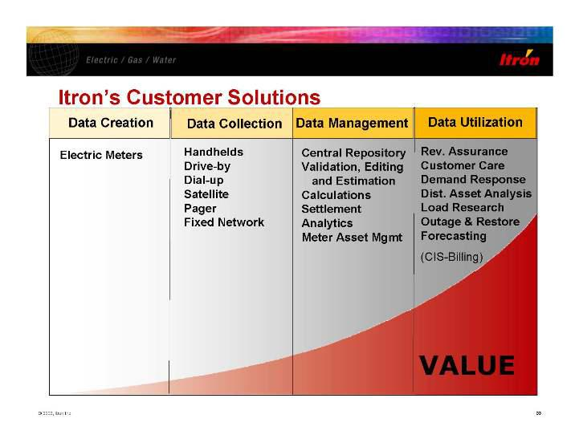

Itron’s Customer Solutions VALUE Data Creation Data Collection Data Management Rev. Assurance Customer Care Demand Response Dist. Asset Analysis Load Research Outage & Restore Forecasting (CIS-Billing) Data Utilization Central Repository Validation, Editing and Estimation Calculations Settlement Analytics Meter Asset Mgmt Handhelds Drive-by Dial-up Satellite Pager Fixed Network Electric Meters

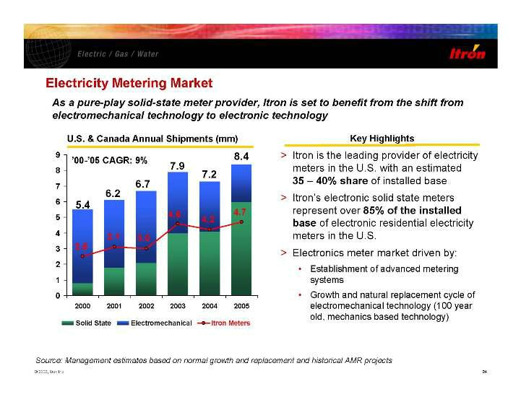

4.7 4.2 4.6 3.0 3.1 2.5 0 1 2 3 4 5 6 7 8 9 2000 2001 2002 2003 2004 2005 Solid State Electromechanical Itron Meters U.S. & Canada Annual Shipments (mm) Key Highlights As a pure-play solid-state meter provider, Itron is set to benefit from the shift from electromechanical technology to electronic technology > Itron is the leading provider of electricity meters in the U.S. with an estimated 35 - 40% share of installed base > Itron’s electronic solid state meters represent over 85% of the installed base of electronic residential electricity meters in the U.S. > Electronics meter market driven by: • Establishment of advanced metering systems • Growth and natural replacement cycle of electromechanical technology (100 year old, mechanics based technology) 5.4 6.2 6.7 7.9 7.2 8.4 Electricity Metering Market ’00-’05 CAGR: 9% Source: Management estimates based on normal growth and replacement and historical AMR projects

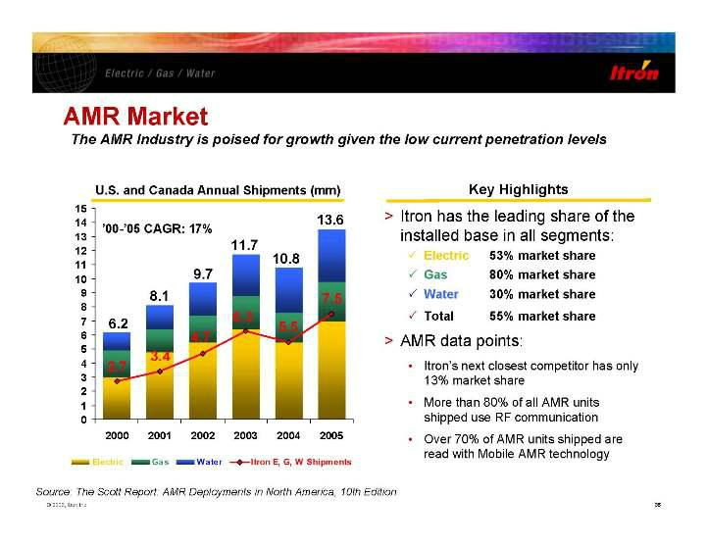

7.5 5.5 6.3 4.7 3.4 2.7 0 1 2 3 4 5 6 7 8 9 10 11 12 13 14 15 2000 2001 2002 2003 2004 2005 Electric Gas Water Itron E, G, W Shipments Source: The Scott Report: AMR Deployments in North America, 10th Edition U.S. and Canada Annual Shipments (mm) Key Highlights 6.2

8.1 9.7 11.7 10.8 13.6’00-’05 CAGR: 17% > Itron has the leading share of the installed base in all segments: 3 Electric 53% market share 3 Gas 80% market share 3 Water 30% market share 3 Total 55% market share > AMR data points: • Itron’s next closest co 13% market share

• More than 80% of all AMR units shipped use RF communication • Over 70% of AMR units shipped are read with Mobile AMR technology AMR Market The AMR Industry is poised for growth given the low current penetration levels

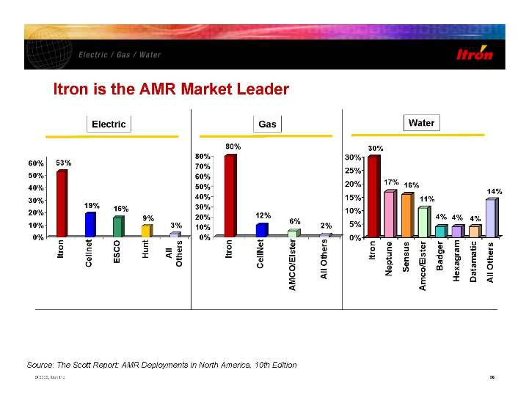

Itron is the AMR Market Leader 53% 19% 16% 9% 3% 0% 10% 20% 30% 40% 50% 60% Itron Cellnet ESCO Hunt All Others 80% 12% 6% 2% 0% 10% 20% 30% 40% 50% 60% 70% 80% Itron CellNet AMCO/Elster All Others Electric Gas Water 30% 17% 16% 11% 4% 4% 4% 14% 0% 5% 10% 15% 20% 25% 30% Itron Neptune Sensus Amco/Elster Badger Hexagram Datamatic All Others ents in North America, 10th Edition

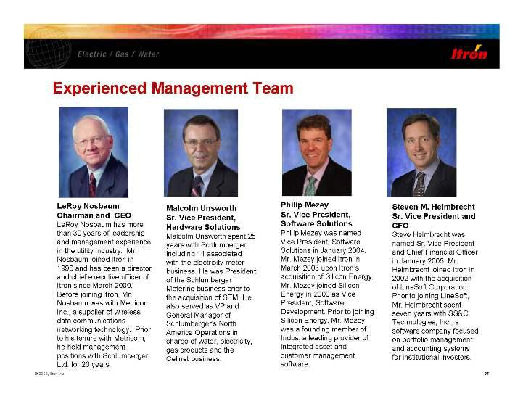

Experienced Management Team LeRoy Nosbaum Chairman and CEO LeRoy Nosbaum has more than 30 years of leadership and management experience in the utility industry. Mr. Nosbaum joined Itron in 1996 and has been a director and chief executive officer of Itron since March 2000. Before joining Itron, Mr. Nosbaum was with Metricom Inc., a supplier of wireless data communications networking technology. Prior to his tenure with Metricom, he held management positions with Schlumberger, Ltd. for 20 Malcolm Unsworth Sr. Vice President, Hardware Solutions Malcolm Unsworth spent 25 years with Schlumberger, including 11 associated with the electricity meter business. He was President of the Schlumberger Metering business prior to the acquisition of SEM. He also served as VP and General Manager of Schlumberger’s North America Operations in charge of water, electricity, gas products and the Cellnet business. Philip Mezey Sr. Vice President, Software Solutions Philip Mezey was named Vice President, Software Solutions in January 2004. Mr. Mezey joined Itron in March 2003 upon Itron’s acquisition of Silicon Energy. Mr. Mezey joined Silicon Energy in 2000 as Vice President, Software Development. Prior to joining Silicon Energy, Mr. Mezey was a founding member of Indus, a leading provider of integrated asset and customer management software. Steven M. Helmbrecht Sr. Vice President and CFO Steve Helmbrecht was named Sr. Vice President and Chief Financial Officer in January 2005. Mr. Helmbrecht joined Itron in 2002 with the acquisition of LineSoft Corporation. Prior to joining LineSoft, Mr. Helmbrecht spent seven years with SS&C Technologies, Inc., a software company focused on portfolio management and accounting systems for institutional investors.

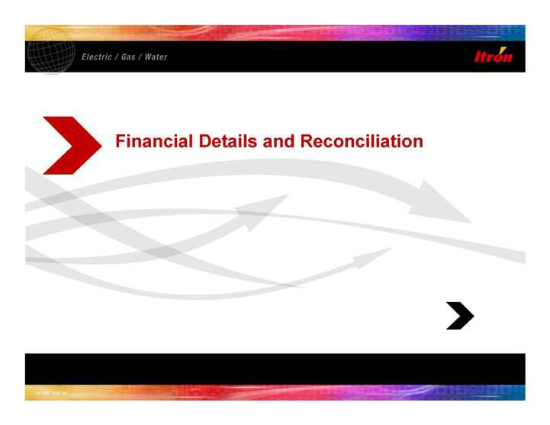

Financial Details and Reconciliation

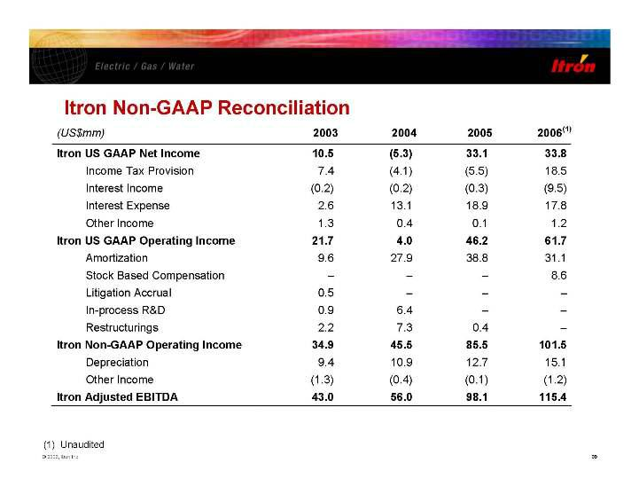

Itron Non-GAAP Reconciliation (US$mm) 2003 2004 2005 2006(1) Itron US GAAP Net Income 10.5 (5.3) 33.1 33.8 Income Tax Provision 7.4 (4.1) (5.5) 18.5 Interest Income (0.2) (0.2) (0.3) (9.5) Interest Expense 2.6 13.1 18.9 17.8 Other Income 1.3 0.4 0.1 1.2 Itron US GAAP Operating Income 21.7 4.0 46.2 61.7 Amortization 9.6 27.9 38.8 31.1 Stock Based Compensation - - - 8.6 Litigation Accrual 0.5 - - - In-process R&D 0.9 6.4 - - Restructurings 2.2 7.3 0.4 - Itron Non-GAAP Operating Income 34.9 45.5 85.5 101.5 Depreciation 9.4 10.9 12.7 15.1 Other Income (1.3) (0.4) (0.1) (1.2) Itron Adjusted EBITDA 43.0 56.0 98.1 115.4 (1) Unaudited

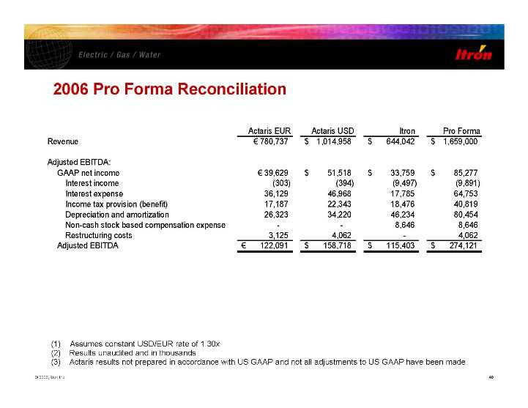

2006 Pro Forma Reconciliation Actaris EUR Actaris USD Itron Pro Forma Revenue € 780,737 1,014,958 $ 644,042 $ 1,659,000 $ Adjusted EBITDA: GAAP net income € 39,629 51,518 $ 33,759 $ 85,277$ Interest income (303) (394) (9,497) (9,891) Interest expense 36,129

46,968 17,785 64,753 Income tax provision (benefit) 17,187 22,343 18,476 40,819 Depreciation and amortization 26,323 34,220 46,234 80,454 Non-cash stock based compensation expense --8,646 8,646 Restructuring costs 3,125 4,062 -4,062 Adjusted EBITDA 122,091 €

158,718 $ 115,403 $ 274,121 $ (1) Assumes constant USD/EUR rate of 1.30x (2) Results unaudited and in thousands (3) Actaris results not prepared in accordance with US GAAP and not all adjustments to US GAAP have been made

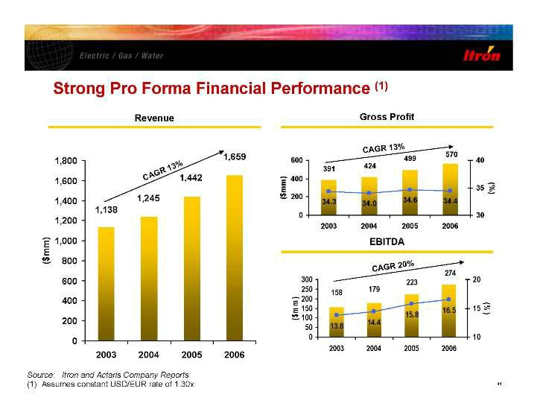

Strong Pro Forma Financial Performance (1) 1,138 1,245 1,442 1,659 0 200 400 600 800 1,000 1,200 1,400 1,600 1,800 2003 2004 2005 2006 ($mm) Revenue Gross Profit Source: Itron and Actaris Company Reports (1) Assumes constant USD/EUR rate of 1.30x 570499 424391 34.3 34.0 34.6 34.4 0 200 400 600 2003 2004 2005 2006 ($mm) 30 35 40 (%) EBITDA CAGR13% CAGR 13% 274 223 179 158 13.8 14.4 15.8 16.5 0 50 100 150 200 250 300 2003 2004 2005 2006 ($m m ) 10 15 20 (% ) CAGR20%

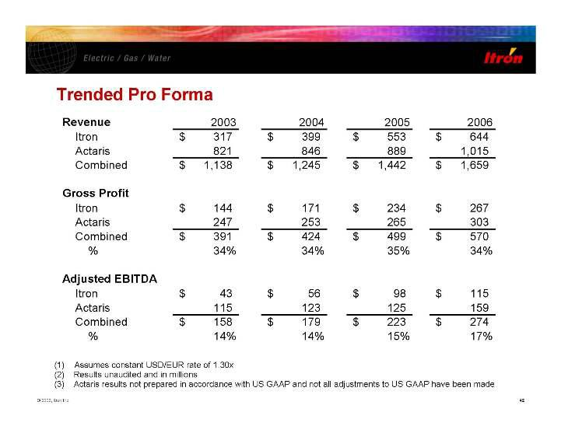

Trended Pro Forma Revenue 2003 2004 2005 2006 Itron 317$ $ 399 $ 553 $ 644 Actaris 821 846 889 1,015 Combined 1,138$ $ 1,245 $ 1,442 $ 1,659 Gross Profit Itron 144$ $ 171 $ 234 $ 267 Actaris 247 253 265 303 Combined 391$ $ 424 $ 499 $ 570 % 34% 34% 35% 34% Adjusted EBITDA Itron 43$ $ 56 $ 98 $ 115 Actaris 115 123 125 159 Combined 158$ $ 179 $ 223 $ 274 % 14% 14% 15% 17% (1) Assumes constant USD/EUR rate of 1.30x (2) Results unaudited and in millions (3) Actaris results not prepared in accordance with US GAA P and not all a djustmen ts to US GAA P have been made

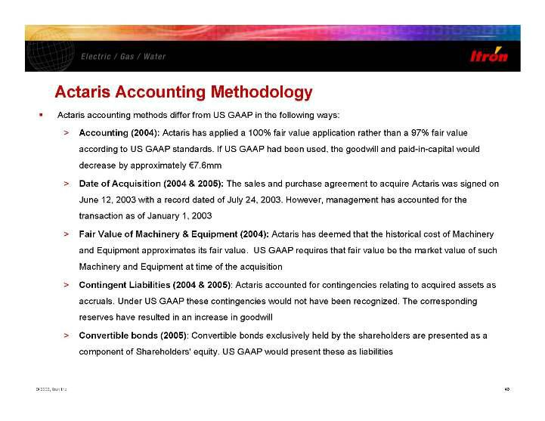

- Actaris accounting methods differ from US GAAP in the following ways: > Accounting (2004): Actaris has applied a 100% fair value application rather than a 97% fair value according to US GAAP standards. If US GAAP had been used, the goodwill and paid-in-capital would decrease by approximately €7.6mm > Date of Acquisition (2004 & 2005): The sales and purchase agreement to acquire Actaris was signed on June 12, 2003 with a record dated of July 24, 2003. However, management has accounted for the transaction as of January 1, 2003 > Fair Value of Machinery & Equipment (2004): Actaris has deemed that the historical cost of Machinery and Equipment approximates its fair value. US GAAP requires that fair value be the market value of such Machinery and Equipment at time of the acquisition > Contingent Liabilities (2004 & 2005): Actaris accounted for contingencies relating to acquired assets as accruals. Under US GAAP these contingencies would not have been recognized. The corresponding reserves have resulted in an increase in goodwill > Convertible bonds (2005): Convertible bonds exclusively held by the shareholders are presented as a component of Shareholders' equity. US GAAP would present these as liabilities

Exhibit 99.3

Electric / Gas / Water
Information collection, analysis and applications

2111 North Molter Road

Liberty Lake, WA 99019

509.924.9900 Tel

509.891.3355 Fax

www.itron.com

FOR IMMEDIATE RELEASE

ITRON ANNOUNCES $235 MILLION PRIVATE PLACEMENT OF EQUITY

SPOKANE, WA. —February 25, 2007 — Itron, Inc. (NASDAQ:ITRI) announced today that it has agreed to sell 4,086,958 shares of its common stock to ten institutional investors in a private placement at a pric $57.50 per share, based on a 5% discount from the five-day average share closing price during the week of February 12, 2007 of $60.52. The transaction is expected to generate gross proceeds to Itron of $235 mil before fees and other offering expenses. Net proceeds will be used to partially fund the acquisition of Actaris Metering Systems. The sale is expected to be completed on March 1, 2007, subject to customary clo conditions.

The shares being sold have not been registered under the Securities Act of 1933 or any state securities laws and, until so registered, may not be offered or sold in the United States or any state absent an applic exemption from registration requirements. This announcement does not constitute an offer to sell, nor is it a solicitation of an offer to buy, these securities. Pursuant to the terms of the securities purchase agreem with the private placement investors, the Company has agreed to register re-sales of the shares not more than 75 days from the date of closing of the Actaris acquisition.

This press release contains forward-looking statements regarding the expectation of the closing of the private placement. These forward-looking statements are based on Itron's current expectations and are subjec the risk that the closing conditions to the financing are not met which, if this occurs, may cause the closing not to occur.

Itron, Inc. contact:

Deloris Duquette

Vice-president, Investor Relations and Corporate Communications

- 891-3523 Deloris.duquette@itron.com

